**CHAPTER 1**

**INTRODUCTION**

Cardiac arrhythmia poses a grave threat to health, leading to significant complications if left undiagnosed or untreated. Timely identification of arrhythmias is paramount for saving lives. Arrhythmia refers to irregularities in heart rhythm, manifesting as either excessively fast or slow heartbeats. Many arrhythmias manifest without any discernible symptoms, but when they do, individuals may experience sensations like palpitations or moments of heartbeats pausing. In severe cases, symptoms can include dizziness, fainting, breathlessness, or chest discomfort. While most arrhythmias are not inherently life-threatening, some can predispose individuals to grave complications like stroke or heart failure, while others can precipitate cardiac arrest.

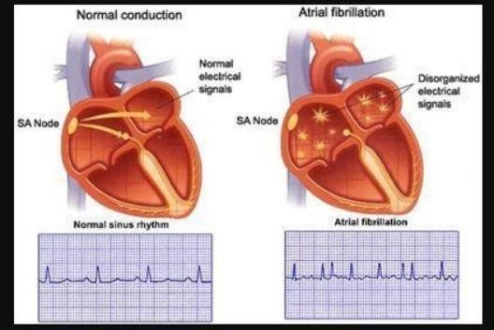Arrhythmia is a widespread affliction, affecting millions globally. A significant proportion of cardiovascular-related deaths can be attributed to arrhythmias, with ventricular arrhythmias accounting for a substantial portion of sudden cardiac deaths. Although arrhythmias can affect individuals of any age, they are more prevalent among older populations. Any disruption to the heart's electrical impulses, responsible for orchestrating its rhythmic contractions, can precipitate arrhythmias. In individuals with healthy hearts, a resting heart rate typically falls within the range of 60-100 beats per minute. Physical fitness can influence resting heart rate, with highly trained athletes often exhibiting lower resting heart rates due to enhanced cardiac efficiency

**Fig1.1. Rhythm of heart beat**

**A few factors can cause the heart to work incorrectly, they include:**

• alcohol abuse.

• diabetes.

• drug abuse.

• excessive coffee consumption.

• heart disease like congestive heart failure.

• hypertension (high blood pressure).

• hyperthyroidism (an overactive thyroid gland).

In the absence of external triggers like substance abuse or electric shocks, a healthy individual typically doesn't experience long-term arrhythmias. However, if there's an underlying issue affecting the heart's electrical pathways, it can disrupt the normal flow of electrical impulses, thereby increasing the likelihood of arrhythmias. Normally, the heartbeat maintains a steady, regular rhythm at an optimal pace. However, deviations from this norm, such as a heartbeat that's too fast, too slow, or irregular, indicate a cardiac arrhythmia—a prevalent heart disorder. Interestingly, most people experience occasional instances of cardiac arrhythmias, even though they might not always be noticeable.

Arrhythmias occur due to disturbances in the heart's natural electrical system, responsible for regulating heart rate and rhythm. The severity of arrhythmias can vary greatly. While some are entirely harmless and inconsequential, others pose significant risks, even being potentially life-threatening. Additionally, many arrhythmias, although not inherently dangerous, can cause disruptive symptoms that significantly impact an individual's quality of life.

**Electrocardiogram (ECG):**

The heartbeat is initiated by the heart's electrical system, with each heartbeat reflected as a wave on an electrocardiogram (EKG or ECG). Cardiac arrhythmias encompass a spectrum of severity, ranging from mild to severe. While most arrhythmias are benign and pose little risk, some can be extremely dangerous and life-threatening. Many arrhythmias, even if not particularly harmful, can cause troublesome symptoms that disrupt daily life. The Sinoatrial Node (SA node), also known as the Sinus Node, is a small cluster of cardiac tissue responsible for generating electrical impulses that coordinate the heart's contractions. These impulses begin in the right atrium, prompting both atria to contract before reaching the atrioventricular (AV) node, which connects the atria and ventricles. The normal resting heart rate for adults typically falls between 60 to 90 beats per minute, while children tend to have higher resting heart rates. Conversely, trained athletes often exhibit lower resting heart rates,

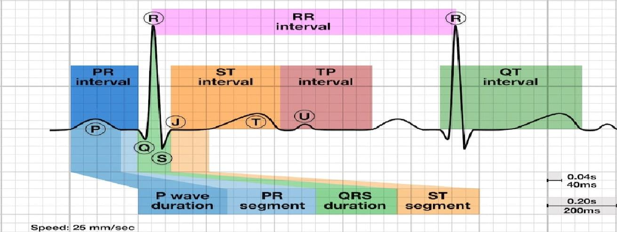

**Fig1.2: Electrocardiogram**

**Differential Diagnosis:**

* **Normal Electrical Activity:** Sinus arrhythmia represents an irregular heartbeat characterized by fluctuations in heart rate, notably accelerating and decelerating in sync with inhalation and exhalation. This phenomenon is commonly observed in children and tends to diminish with age. On an electrocardiogram (ECG), normal sinus activity is denoted by solid black arrows, indicating active sinus nodes. However, there are intermittent periods of node inactivity, resulting in temporary pauses in heartbeats. During these pauses, indicated by dashed arrows on the ECG, the P wave pattern deviates from the typical rhythm, suggesting an alternate origin within the atrium.
* **Bradycardias**: Bradycardia refers to a slower than normal heart rate, typically below 60 beats per minute. This condition can arise from various causes, including sinus arrest, where the electrical impulse between the atria and ventricles is obstructed, or sinus bradycardia, stemming from a decreased signaling from the sinus node. The severity of bradycardia can vary from mild to severe and may result from reversible factors like medication-induced AV node suppression or irreversible damage to the node itself. Interestingly, bradycardia can also manifest in individuals with high levels of physical fitness, such as endurance athletes, due to their efficient cardiovascular systems. Additionally, certain types of seizures can provoke episodes of bradycardia.
* **Tachycardia:** Tachycardia is characterized by a rapid heart rate, typically exceeding 100 beats per minute during periods of rest in both adults and children over the age of 15. While palpitations are a common symptom of tachycardia, it's important to note that not all instances of rapid heart rate qualify as arrhythmias. Factors such as physical exertion or emotional stress can elevate heart rate. Sinus tachycardia, for example, results from increased activity of the sympathetic nervous system, which influences the sinus node. This heightened activity is often observed in response to stimuli like caffeine, amphetamines, hyperactive thyroid glands (hyperthyroidism), or conditions like anemia.
* **Heart Defects:** Heart defects present at birth, known as congenital heart defects, involve structural or electrical abnormalities in the heart's pathways. These defects can affect anyone regardless of their overall health status. Disruptions in the heart's electrical pathways can lead to arrhythmias, some of which may progress rapidly and prove fatal. Long QT syndrome, a complex heart disorder, has been associated with increased mortality rates. Fortunately, various treatment options exist, including cardiac ablation, medication, and lifestyle modifications aimed at reducing stress and promoting overall heart health. Each individual cardiac cell possesses the capability to generate a single excitation impulse in any direction within a short timeframe. Ordinarily, the action potential impulse propagates rapidly across the heart, ensuring that each cell responds just once. However, disruptions in the heart's electrical conduction pathways, such as those caused by a refractory phase or sluggish conduction in certain regions, can lead to delayed impulses or the generation of new impulses. This can result in the establishment of abnormal circuit rhythms, depending on the timing and nature of these disruptions.
* **Re-entry:** Re-entry mechanisms, including autowave vortices of excitation within the heart muscle (myocardium), are believed to be a major contributor to the development of potentially fatal cardiac arrhythmias. These autowave vortices are particularly prevalent in the thin walls of the atria, where they often result in a condition known as atrial flutter. Hazardous ventricular tachycardia and paroxysmal supraventricular tachycardia, two common types of serious arrhythmias, are frequently attributed to re-entry phenomena.

**1.1. PROBLEM STATEMENT:**

The early diagnosis and accurate prediction of cardiac arrhythmia using machine learning techniques. The primary focus is on developing a system that can effectively classify and predict this heart condition based on ECG signals. The goal is to create a system that can assist healthcare professionals in diagnosing cardiac arrhythmia promptly and providing appropriate remedies. The importance of integrating machine learning models seamlessly into existing healthcare systems while ensuring usability, ethical considerations, and adaptability to evolving medical guidelines. The diagnosis of heart disease is usually based on signs, symptoms and physical examination of the patient. There are several factors that increase the risk of heart disease, such as smoking habit, body cholesterol level, family history of heart disease, obesity, high blood pressure, and lack of physical exercise. So, we come up with the idea for the heart disease prediction using the machine learning algorithms.

**1.2. OBJECTIVES:**

The objective of employing a machine learning approach for the prediction and classification of cardiac arrhythmia encompasses several key aims: firstly, to enable early detection through the development of algorithms capable of identifying subtle patterns in ECG data indicative of various arrhythmia types; secondly, to establish a robust classification system that accurately differentiates between different arrhythmia subtypes, facilitating precise diagnosis and tailored treatment planning; thirdly, to assess the risk of adverse outcomes associated with specific arrhythmias, allowing for patient risk stratification and personalized intervention strategies; fourthly, to enable real-time monitoring of ECG signals for prompt detection and intervention, thereby enhancing patient safety; fifthly, to seamlessly integrate machine learning models into clinical workflows, ensuring their practical utility and acceptance among healthcare providers; and finally, to continually refine and adapt the models based on ongoing feedback and advancements in arrhythmia research, ensuring their scalability, accuracy, and effectiveness in improving patient outcomes.

**1.3 Existing System:**

Cardiac Arrhythmia is considered a very critical condition where it may cause sudden death of people, though some types of Arrhythmias is not causing death, it leads to some dangerous lifetime health issues. So, it is necessary to predict the type of Arrhythmia in a person. Existing monitoring systems for ECG records utilize algorithms to determine changes in cardiac rhythm. However, accurate identification of arrhythmias classification is known to be challenging even for medical professionals and requires considerable medical expertise. The classification of arrhythmia is not much exposed currently, so we are going to make predictions and classification of cardiac arrhythmia using ECGs as well as the human body’s various factors.

**1.4 Proposed System:**

# An arrhythmia is caused by a disruption of the heart’s normal electrical system, which regulates your heart rate and heart rhythm. The heart’s electrical system triggers the heartbeat. Each beat of the Machine Learning Approach for the Prediction and Classification of Cardiac Arrhythmia heart is represented on the electrocardiogram (ECG) by a waving arm. The normal heart rhythm (normal sinus rhythm) shows the electrical activity in the heart. The rhythm is regular, and the node is normal (about 50 to 100 beats per minute).

# Chapter 2

**Literature Review**

# 2.1. Papers Explanation

# Lit.1. Predictive and Classification of cardiac arrhythmia

# Authors: Vasu Gupta, Sharan Srinivasan, Sneha S Kudli

# In this paper authors discussed about ideas Arrhythmia can be diagnosed by measuring the heart activity using an instrument called ECG or electrocardiograph and then analyzing the recorded data, By using different machine learning algorithms like Naive Bayes, SVM, Random 8 Forests and Neural Networks for predicting and classifying arrhythmia into different categories.

**Lit.2. Classification of Arrhythmia Using Machine Learning 1 Techniques**

**Authors: Thara Soman and Patrick , Bobbie.**

In this paper is the results obtained from extensions of an ongoing major effort, Some of the results of this effort have been partly reported. In the effort, we focused on the acquisition and (software) analysis of ECG signals for early diagnosis of Tachycardia heart disease, Decision tree induction is an algorithm that normally learns a high-accuracy set of rules.

**Lit.3. Prediction of Cardiac Arrhythmia**

**Authors: Varun Kathuria, Prakhar Thapliyal**.

In this paper authors discussed about The total number of deaths due to cardiovascular diseases read 17.3 million a year according to the WHO causes of death, Thus, how to predict cardiac arrhythmia in real life is of great significance. The diagnosis of cardiac arrhythmia can be classified into various classes based on the Electrocardiogram (ECG) readings and other attributes.

**Lit.4. A Novel Approach of ECG Classification for 1 8 Diagnosis of Heart Diseases**

**Authors: Mr. Jitendra Kumar and Ekta Gajendra.**

In this paper authors discussed about An arrhythmia is a problem with 5 the heartbeat rate or rhythm of the heartbeat, the heart may beat too fast or too slow, or with an irregular rhythm, Fast heartbeat is said to be tachycardia whereas slow is called 5 Bradycardia The T wave is generated by relaxation of the ventricles. The P, Q, R, S, T and U waves of the ECG signal contain all the important features that describe the activity in the heart.

**Lit.5. An Efficient Algorithm for Cardiac Arrhythmia Classification Using Ensemble of Depth wise Separable Convolutional Neural Networks**

**Authors: Eko Ihsanto, Kalamullah Ramli, Dodi Sudiana and Teddy Surya Gunawan**

In this paper authors discussed Many algorithms have been developed for automated electrocardiogram (ECG) classification. Due to the non-stationary nature of the ECG signal, it is rather challenging to use traditional handcraft methods, such as time-based analysis of feature extraction and classification, to pave the way for machine learning implementation. This paper proposed a novel method, i.e., the ensemble of depth wise separable convolutional (DSC) neural networks for the classification of cardiac arrhythmia ECG beats. Using our proposed method, the four stages of ECG classification, i.e., QRS detection, preprocessing, feature extraction, and classification, were reduced to two steps only, i.e., QRS detection and classification. No preprocessing method was required while feature extraction was combined with classification. Moreover, to reduce the computational cost while maintaining its accuracy, several techniques were implemented, including All Convolutional Network (ACN), Batch Normalization (BN), and ensemble convolutional neural networks.

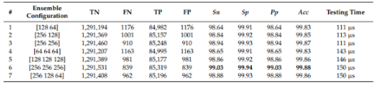

**Table : Performance of Various Ensemble of Depth wise separable CNN configuration**

**2.2. SUMMARY OF TABLE**

| **S.N** | **PAPER TITTLE &**  **PUBLICATION DETAILS** | **NAME OF THE AUTHORS** | **TECHNICAL IDEAS / ALGORITHMS USED IN THE PAPER ADVANTAGES** | **SHORTFALLS/DISADVANTAGES & SOLUTION PROVIDED BY THE PROPOSED SYSTEM** |
| --- | --- | --- | --- | --- |
| 1 | Predictive and Classification of cardiac 8 arrhythmia, 2015. | Vasu Gupta, Sharan Srinivasan, Sneha S Kudli | Naive Bayes, SVM, Random Forests and Neural Networks | Irregularity in heartbeat may be harmless or life-threatening, Hence both accurate detection of presence, as well as classification of arrhythmia, are important. |
| 2 | Classification of Arrhythmia Using Machine Learning 1 Techniques, 2015 | Thara Soman and Patrick . Bobbie | The algorithm uses the greedy technique to induce decision trees for classification. .Decision tree induction is an  Algorithm that normally learns a high-accuracy set of rules. | Traditional classification methods may lack the precision needed to accurately classify certain types of arrhythmias, leading to misdiagnosis or underdiagnosis |
| 3 | Prediction of Cardiac Arrhythmia, 2017 | Varun Kathuria, Prakhar Thapliyal | The diagnosis of cardiac arrhythmia can be classified into various classes based on the Electrocardiogram (ECG) readings and other attributes. This is a supervised learning problem. | The total number of deaths due to cardiovascular diseases read 17.3 million a year according to 12 the WHO causes of death. Thus, how to predict cardiac arrhythmia in real life is of great significance. |
| 4 | A Novel Approach of ECG Classification for 1 8 Diagnosis of Heart Diseases, 2015. | Mr. Jitendra Kumar and Ekta Gajendra | An ECG comprises of the P wave, QRS complex, T and U waves, The P, Q, R, S, T and U waves of the ECG signal contain all the important features that describe the activity in the heart. | Classification of cardiac arrhythmia is a difficult task. One ofthe ways to detect cardiac arrhythmia is to use electrocardiogram (ECG) signals. |
| 5 | An Efficient 29 Algorithm for Cardiac Arrhythmia Classification Using Ensemble of Depth wise Separable Convolutional Neural Network, 2019-2020. | Eko Ihsanto, Kalamullah Ramli, Dodi Sudiana and Teddy Surya Gunawan | This paper proposed a novel method, i.e., the ensemble of depth wise separable convolutional (DSC) neural networks for the classification of cardiac arrhythmia ECG beats. including All Convolutional Network (ACN), Batch Normalization (BN), and ensemble convolutional neural networks. | Some arrhythmias may exhibit complex patterns that are difficult to interpret accurately using conventional techniques. |

**CHAPTER 3**

**REQUIREMENTS**

A requirement is a statement about what the proposed system will do that help to solve the customer’s problem that we are focusing on. Requirements can be divided into major types, functional and non-functional. Requirements documents normally include both of them.

**3.1.FUNCTIONAL REQUIREMENTS:**

Functional Requirements describe what the system should do, i.e. the services provided for the users.

* **Data input:** The programme ought to support the entry of Signals from electrocardiograms in a common format, like.csv or.txt.
* **Signal processing:** To eliminate noise and artefacts and extract pertinent characteristics from the ECG data, the system's algorithms should preliminary processing and filter the signals.
* **Training a machine learning model:** Using a labelled dataset of ECG signals, the algorithm must build a deep CNN model to categorise patients as healthy or ill.
* **Classification output:** Based upon the trained CNN model, the system should output a binary classification for each ECG signal.
* **Classification output:** Based upon the trained CNN model, the system should output a binary classification for each ECG signal.
* **Evaluation of correctness:** The system should include measures like specificity, sensitivity, precision, and AUC to assess how well the trained model performed.
* **Security:** The system must guarantee the patient data's security and privacy and adhere to data protection laws.
* **Maintenance and updates:** To guarantee the system's continuous correctness and dependability, it should contain provision for maintaining, updates, and upgrades.
* **Compatibility:** The system has to work with common operating systems and web browsers.
* **User manuals and support:** The software has to include clear, thorough documentation and help for users who need to solve problems or get more information.

**3.2.NON-FUNCTIONAL REQUIREMENTS:**

Non-functional requirements are constraints that must be adhered to during development. They limit what resources can be used and set bounds on aspects of the software’s quality. When designing a machine learning system for heart disease prediction, there are several non-functional requirements to consider. Non-functional requirements define the system's qualities and constraints rather than its specific functionalities. Here are some important non-functional requirements for a heart disease prediction system using ML techniques:

* **Accuracy:** The ML model should exhibit a high level of accuracy in predicting heart disease. It should be able to correctly identify individuals with heart disease and distinguish them from those without the condition.
* **Performance:** The system should be capable of providing predictions within an acceptable timeframe. The inference time should be optimized to ensure quick responses to user queries or requests for predictions.
* **Reliability:** It should be robust enough to handle variations in input data and still produce accurate predictions.
* **Scalability:** The system should be able to handle a growing number of users and increasing amounts of data without significant degradation in performance. It should scale effectively to accommodate increased computational demands.
* **Privacy and Security:** The system should adhere to privacy regulations and protect sensitive patient data. It should incorporate robust security measures to prevent unauthorized access, data breaches, or tampering with the ML model or the underlying data.
* **Interpretability:** Although ML models often operate as black boxes, for medical applications like heart disease prediction, it is crucial to provide some level of interpretability. The system should offer explanations or justifications for its predictions, enabling healthcare professionals to understand and trust the results.
* **Adaptability:** The ML model should be adaptable and capable of learning from new data. It should have mechanisms to incorporate updated knowledge or medical guidelines, allowing it to evolve and improve its predictions over time.
* **Usability:** The system should have a user-friendly interface that enables healthcare professionals to interact with the model effectively. It should provide clear instructions, visualizations, and intuitive controls to facilitate easy interpretation of results.
* **Ethical Considerations:** The development and deployment of the system should adhere to ethical guidelines and principles. This includes ensuring fairness and avoiding bias in predictions, protecting vulnerable populations, and considering the potential social impact of the technology.
* **Integration:** The ML system should be designed for seamless integration with existing healthcare systems, electronic health records (EHRs), or other relevant systems. It should support data exchange and interoperability standards, allowing for efficient data sharing.

**3.3. SOFTWARE REQUIREMENTS:**

* Operating system: Windows .
* Coding language: python or R language.
* IDE: Anaconda Navigator Jupyter Notebook or R Studio.
* Libraries: Matplotlib, Seaborn, Numpy, Pandas, SK learn Open CV OS.

**3.4. HARDWARE REQUIREMENTS:**

* Processor: 64-bit 2.8GHz.
* Ram: 8GB or higher.
* Hard Disk: 500GB.
* Input device: Standard Keyboard and Mouse.
* Compact Disk: 650Mb.
* Output device: High-Resolution Monitor.

**CHAPTER 4**

**PROJECT DESIGN**

A conceptual framework illustrating the organization, functionality, and various viewpoints of a system is referred to as system architecture, also termed systems design. An architectural depiction serves as a structured portrayal of a system, facilitating comprehension of its structures and functionalities. Both subsystems and system elements collaborating to construct the overarching system can constitute components of system architecture.

**4.1 Use Case Diagram**

A use case diagram visually represents the potential interactions between a user and a system. It illustrates different scenarios of user interactions and identifies the various types of users interacting with the system. Often, use case diagrams are supplemented with additional types of diagrams to provide a comprehensive understanding of the system's functionality and user interactions.

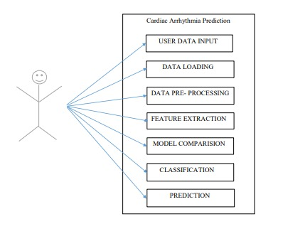

**Fig4.1: Use Case Diagram for Cardiac Arrhythmia Prediction**

**4.2 System Architecture for the Proposed System**

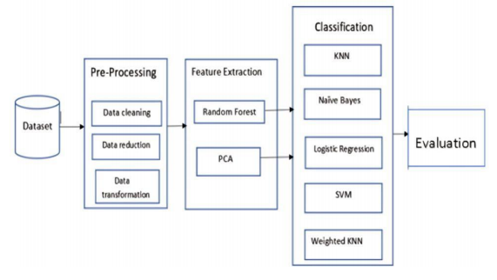

**Fig4.2: System Architecture for the Proposed System.**

* **Data Extraction:** The initial stage of system processing involves gathering data, for which we employ the UCI repository dataset. This dataset has undergone rigorous validation by multiple researchers and the UCI authority.

A structured and numerical dataset derived from electrocardiogram (ECG) data is utilized, taking into account variables such as heart rate, R-R interval, deflection count, height, gender, and other relevant factors. The dataset utilized in this study is sourced from the UCI Machine Learning Repository. Subsequently, a CSV file is generated to store and manage the collected data.

* **Preprocessing:** In preparation for the classification process, the dataset undergoes preprocessing due to issues like missing values and data inconsistencies. Redundant variables, identical across subjects, are removed to streamline the analysis. Invariant attributes are identified through the assessment of variance or standard deviation values. To address the remaining missing data, average values are employed for imputation.
* **Feature Extraction:** Two methods are employed for feature selection: Random Forest and Principal Component Analysis (PCA). Given the preprocessed dataset containing numerous attributes, the chosen categorization strategy demands significant effort. Feature selection becomes crucial to streamline the process and identify the most relevant characteristics closely associated with the output class. Within the dataset, there may be instances of data duplication or repetition of diseases. To address this issue, the random forest algorithm is utilized for classification, aiding in the reduction of redundant data.
* **Classification:** The third phase, known as the classification stage, holds significant importance in the machine learning model. In this stage, we incorporate five algorithms: K-Nearest Neighbors (KNN), Support Vector Machine (SVM), Naïve Bayes, Logistic Regression, and Random Forest. Through feature reduction in the preceding stage, the dataset is streamlined and stored in a CSV file. Subsequently, utilizing this data, metrics such as accuracy, precision, recall, and F1 score are computed.
* **Evaluation:** The effectiveness of each approach is assessed and demonstrated, after which the identified attributes are utilized as input for the subsequent five classification processes.

**4.3 Data Flow Diagram**

Data "flow" within an information system is visually depicted through a data flow diagram, which highlights various process components. Typically serving as the initial phase to provide a broad system overview, a data flow diagram offers a concise representation without delving into intricate details. Additionally, data processing can be depicted through data flow diagrams, showcasing structured design.

A data flow diagram, as depicted in the Figure, illustrates different data types: input into the system, output from the system, flow within the system, and storage. Unlike structured flowcharts that emphasize control flow or UML activity workflow diagrams illustrating both control and data flows, data flow diagrams do not indicate process timing or whether activities occur sequentially or concurrently. Initially, data is extracted from a CSV file, followed by dataset processing. Data processing encompasses filtering of measured signals, essential due to noise and artifacts present in real ECG data such as those caused by breathing and chest movement. This phase includes handling missing data, encoding categorical data, and partitioning the dataset into training and testing subsets.Subsequently, the model undergoes training, feature selection, and dimensionality reduction processes. Learning techniques are then applied to categorize the data. Dimensionality reduction is achieved through Principal Component Analysis (PCA) and Random Forest. KNN, SVM, and NB algorithms are employed to classify arrhythmias into 13 distinct categories.

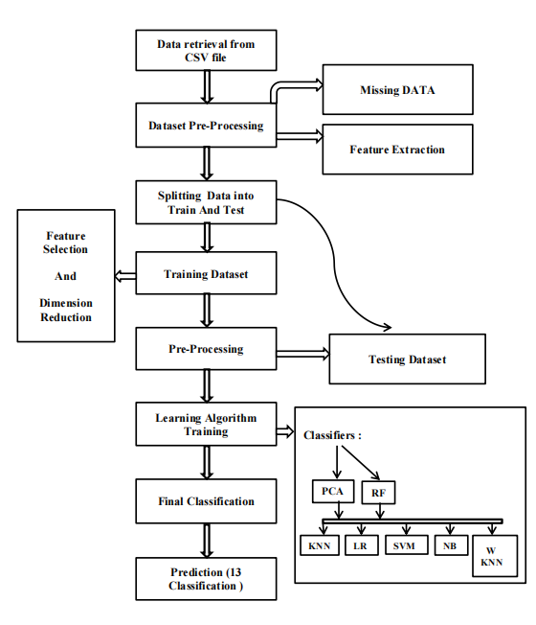

**Fig4.3: Data Flow Diagram**

**CHAPTER 5**

**PROJECT IMPLEMENTATION**

**5.1.Methodology:**

**1. Collection of Dataset:**

* Pre-processing involves refining raw data to prepare it for algorithmic analysis.
* Raw data, initially unstructured, lacks suitability for direct analysis and requires transformation.
* A critical initial step in machine learning involves obtaining and formatting datasets, often stored in CSV files, for integration into analysis and modeling workflows.

**2. Importing Libraries:**

To perform data preprocessing in Python, we need to utilize specific predefined libraries:

* NumPy: This library is crucial for mathematical operations and handling multi-dimensional arrays and matrices.
* Matplotlib: With its sub-library pyplot, Matplotlib is essential for creating various types of charts and plots in Python.
* Pandas: This widely-used library excels in importing, organizing, and managing datasets, offering powerful data manipulation and analysis tools.
* Seaborn: Building upon Matplotlib, Seaborn provides visually appealing and informative statistical visualizations, enhancing data exploration and analysis capabilities.

**3. Importing the Dataset:**

Incorporate the datasets compiled for our machine learning endeavor into the project's codebase.

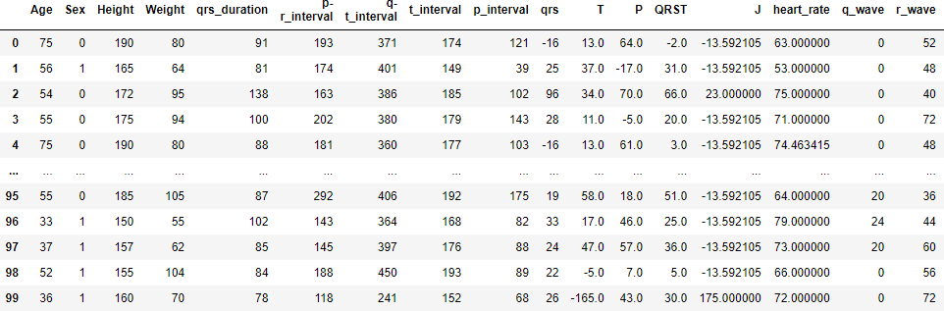

**Table 5.1.1: Importing of dataset**

**4. Handling Missing data:**

* If our dataset contains any missing values, it can significantly impact the performance of our machine-learning model. Therefore, it's crucial to handle these missing values during data preprocessing to ensure the accuracy and reliability of our model.
* There are mainly two ways to this,
* **By deleting a particular row:** The commonly used method involves removing rows or columns containing null values. However, this approach can lead to loss of valuable information and potentially affect model accuracy.
* **By calculating the mean:** Another strategy involves calculating the mean of the column or row with missing values and substituting it for the missing data. This technique is particularly beneficial for numeric features like age, salary, or year, preserving dataset integrity while addressing missing data concerns.

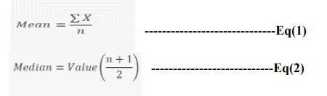

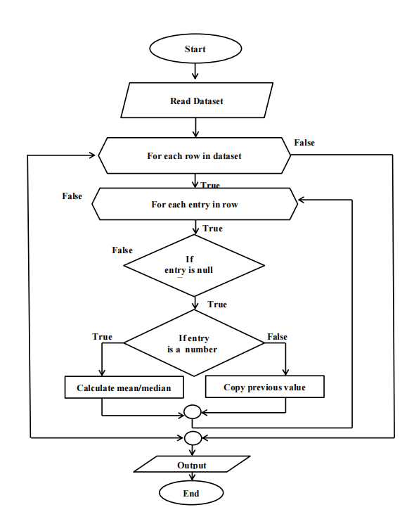

**Fig 5.1.1 : Flow of Data Imputation**

Consider the given dataset,

|  |  |
| --- | --- |
| **SI NO** | **Age** |
| 1 | 45 |
| 2 | 50 |
| 3 | NA |
| 4 | 35 |
| 5 | 40 |

**Table 5.1.2: Mean value calculation**

The missing value at index 3 is found using mean = (45+50+35+40)/4 = 42.5.

**5. Encoding Categorical data:**

* Categorical variables such as Gender, Name, and diagnosis in our dataset can impede machine learning models that operate solely on numerical data, necessitating encoding for compatibility.
* Converting categorical variables into numerical representations through encoding is essential to facilitate mathematical operations required by machine learning models during training and prediction.

Consider the given dataset,

|  |  |
| --- | --- |
| Gender | Gender |
| male | 0 |
| female | 1 |
| female | 1 |
| male | 0 |
| male | 0 |

**Table5.1.3:** **Categorical Data Transformation.**

In the above given dataset Gender attribute has two values (male and female), the male is replaced by 0 and female is replaced by 1.

**6. Feature Extraction:**

* Feature extraction involves converting raw data into numerical representations while retaining essential information, leading to improved performance compared to using raw data directly in machine learning.
* During dataset training, the significance of each feature's contribution to reducing impurity can be quantified, with features exhibiting greater impurity reduction considered more important, especially in random forest models.
* Principal Component Analysis (PCA) necessitates obtaining Eigenvectors and Eigenvalues from the normalized covariance matrix of the data, which involves normalizing the data and then calculating the covariance matrix to facilitate PCA.

**7. Splitting the Dataset into the Training set and Test set:**

* In the process of data preprocessing in machine learning, a pivotal step involves partitioning the dataset into a training set and a test set. This division is critical as it allows us to improve the performance of our machine-learning model.
* Ensuring that the model performs well not only on the training set but also on unseen data is paramount. Therefore, we aim to develop a model that demonstrates robust performance across both the training and test datasets.
* Training Set: This subset of the dataset is utilized to train the machine learning model, where the corresponding outputs are already known.
* Test Set: Another subset of the dataset is reserved for testing the machine learning model. By employing the test set, the model can make predictions, which are then evaluated against the actual outputs.

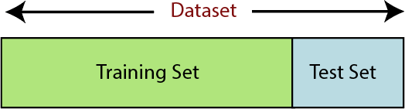

**Fig 5.1.2. : Dataset splitting**

**7. Prediction and Accuracy:**

* Accuracy in classification problems indicates the proportion of correct predictions made by a model, offering insight into its performance.
* It is calculated by dividing the number of correct predictions by the total number of predictions made, providing a measure of the model's predictive accuracy.

**5.2. ML Algorithms:**

**1. Random Forest:**

* Random Forest, a prominent supervised learning algorithm, is versatile in handling both Classification and Regression tasks in machine learning.
* Employing ensemble learning principles, Random Forest amalgamates multiple decision trees, each trained on different subsets of the dataset, to enhance predictive accuracy by averaging their outcomes.
* Unlike relying on a single decision tree, Random Forest aggregates predictions from each tree and determines the final output based on the majority vote, reducing the risk of overfitting.
* The inclusion of numerous trees in the forest augments accuracy and mitigates overfitting concerns, contributing to the algorithm's robustness.
* In this project, Random Forest in conjunction with Principal Component Analysis (PCA) is utilized to identify principal attributes. By leveraging Random Forest with PCA, erroneous or redundant data points are identified and removed, resulting in a refined dataset, termed "reduced features," comprising 107 relevant attributes.

**Algorithm 1: Random Forest**

The Working process can be explained in the below steps:

**Step-1:** Select random K data points from the training set.

**Step-2:** Build the decision trees associated with the selected data points (Subsets).

**Step-3:** Choose the number N for the decision trees that you want to build.

**Step-4:** Repeat Steps 1 & 2.

**Step-5:** For new data points, find the predictions of each decision tree, and assign the new data points to the category that wins the majority votes.

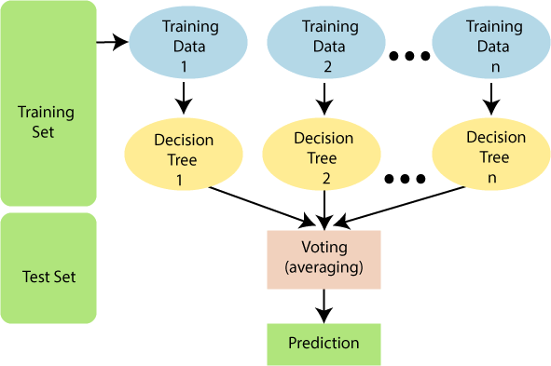

**Fig 5.2.1 : Random Forest**

**2. K- Nearest Neighbour:**

* K-Nearest Neighbors (KNN) is a straightforward supervised machine learning algorithm that operates on the principle of similarity between data points.
* It categorizes new data points by comparing them to existing data points and assigning them to the category most similar to their neighbors.
* The algorithm stores all available data and classifies new data points based on their similarity to the stored data.
* For instance, in image classification, KNN can determine whether an image is of a cat or a dog by comparing its features to those of known cat and dog images.
* In this project, KNN is utilized to assess the accuracy of the dataset. The process involves importing the KNN library, dividing the dataset into training and testing sets, and computing accuracy using the accuracy score, yielding a result of 56.4% accuracy.
* KNN makes classifications based on the Euclidean distance between data points, determining the nearest neighbors to classify a new instance

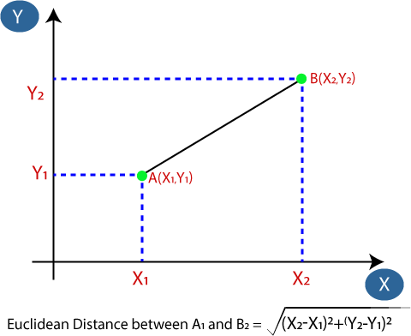

**Fig 5.2.2 : Euclidean Distance**

The K-NN working can be explained on the basis of the below algorithm:

**Step-1:** Select the number K of the neighbors.

**Step-2:** Calculate the Euclidean distance of **K number of neighbors.**

**Step-3:** Take the K nearest neighbors as per the calculated Euclidean distance.

**Step-4:** Among these k neighbors, count the number of data points in each category.

**Step-5:** Assign the new data points to that category for which the number of neighbors is maximum.

**Algorithm 2: K-Nearest Neighbors**

|  |  |  |  |  |
| --- | --- | --- | --- | --- |
| 50-50 | 54.86 | 10.69 | 17.23 | 9.32 |
| 60-40 | 56.45 | 10.89 | 17.64 | 10.36 |
| 70-30 | 56.01 | 10.86 | 14.56 | 9.67 |
| 80-20 | 52.76 | 10.8 | 14.53 | 10.63 |
| 90-10 | 54.41 | 13.72 | 13.54 | 13.62 |

**Table 5.2.1: Performance Metrics for KNN**

**3. SVM Classifier:**

* Support Vector Machine (SVM) stands out as a highly favored supervised learning algorithm suitable for both Classification and Regression tasks.
* The primary objective of SVM is to establish an optimal decision boundary or hyperplane in the feature space to effectively separate different classes, facilitating accurate categorization of new data points.
* SVM identifies critical data points, known as support vectors, which play a pivotal role in defining the hyperplane, thereby contributing to the algorithm's name.
* In the context of this project, SVM is utilized to assess the dataset's accuracy. The procedure entails importing the SVM library, dividing the dataset into training and testing subsets, and subsequently calculating accuracy using the accuracy score function, yielding an accuracy of 96.67%.

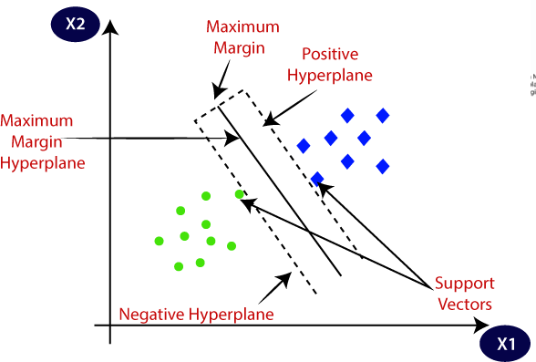

**Fig 5.2.3 :Support Vector Machine**

|  |  |  |  |  |
| --- | --- | --- | --- | --- |
| **Train-Test** | **Accuracy Score** | **Precision Score** | **Recall** | **F1 Score** |
| 50-50 | 0.8377 | 74.3 | 69.35 | 67.32 |
| 60-40 | 87.63 | 85.6 | 87.36 | 85.23 |
| 70-30 | 92.87 | 97.64 | 92.03 | 92.03 |
| 80-20 | 95.94 | 98.96 | 97.96 | 97.96 |
| 90-10 | 96.32 | 97.79 | 99.69 | 98.96 |

**Table 5.2.2: Performance Metrics of SVM**

**4. Logistic Regression:**

* Logistic Regression, a prevalent algorithm in Machine Learning, falls under the umbrella of Supervised Learning, primarily employed for predicting categorical outcomes based on a set of independent variables.
* Unlike Linear Regression, which is geared towards regression tasks, Logistic Regression specializes in classification problems, where the output is discrete and categorical, such as binary outcomes like Yes or No, True or False, represented as probabilities ranging between 0 and 1.
* Logistic Regression's utility lies in its capability to furnish probabilities and classify new data points, making it a versatile tool for handling both continuous and discrete datasets with the aim of making accurate predictions.
* Logistic Regression equation is given below,

Logistic Regression in Machine Learning

**------------------Eq(4)**

* Logistic Regression is adept at categorizing observations across diverse data types and can efficiently identify the most influential variables crucial for classification. Illustrated below is the logistic function, demonstrating its ability to model the probability of categorical outcomes based on input features**.**

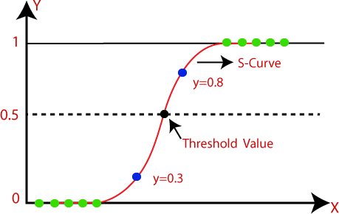

**Fig 5.2.4 : Logistic Regression Function**

Utilizing Logistic Regression, the dataset's accuracy is evaluated by importing the necessary library, dividing the dataset into training and testing sets, and subsequently calculating accuracy using an accuracy score function, resulting in an accuracy of 54.61%.

|  |  |  |  |  |
| --- | --- | --- | --- | --- |
| **Train-Test** | **Accuracy Score** | **Precision Score** | **Recall** | **F1 Score** |
| 50-50 | 55.6 | 28.61 | 46.87 | 31.67 |
| 60-40 | 58.3 | 25.23 | 33.58 | 27.62 |
| 70-30 | 57.49 | 31.66 | 53.57 | 32.61 |
| 80-20 | 57.93 | 33.71 | 39.58 | 34.62 |
| 90-10 | 58.82 | 26.68 | 32.59 | 27.63 |

**Table 5.2.3: Performance Metrics for Logistic Regression**

**5. Naïve Bayes:**

* Naïve Bayes is a supervised learning algorithm based on Bayes' theorem, widely used for classification problems.
* It finds its primary application in text classification, especially with high-dimensional training datasets.
* Operating as a probabilistic classifier, Naïve Bayes predicts based on the probability of an object.
* Bayes' theorem, also known as Bayes' Rule, calculates the probability of a hypothesis given prior knowledge, relying on conditional probability.
* The formula for Bayes' theorem is given as,

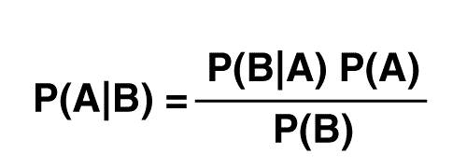

* Posterior probability (P(A|B)): Probability of hypothesis A given the observed event.
* Likelihood probability (P(B|A)): Probability of the evidence given that the hypothesis is true.
* Prior Probability (P(A)): Probability of the hypothesis before observing the evidence.
* Marginal Probability (P(B)): Probability of evidence.
* Naïve Bayes is utilized to assess dataset accuracy by importing the necessary library, splitting the dataset into training and testing sets, and measuring accuracy using an accuracy score function.
* The resulting accuracy from Naïve Bayes for the given dataset is 16.23%.

|  |  |  |  |  |
| --- | --- | --- | --- | --- |
| **Train-Test** | **Accuracy Score** | **Precision Score** | **Recall** | **F1 Score** |
| 50-50 | 19.02 | 39.68 | 29.87 | 24.38 |
| 60-40 | 16.42 | 41.44 | 26.16 | 21.14 |
| 70-30 | 13.02 | 47.61 | 32.13 | 24.12 |
| 80-20 | 14.39 | 41.69 | 27.14 | 20.13 |
| 90-10 | 13.23 | 23.54 | 17.13 | 10.1 |

**Table 5.2.4: Performance Metrics for Naïve Bayes**

**6. Weighted KNN:**

* Weighted KNN, a variation of k-nearest neighbors, addresses performance issues related to the choice of the hyperparameter k.
* The performance of the KNN algorithm is influenced by the selection of the hyperparameter k, where a small k increases sensitivity to outliers, while a large k may include too many points from other classes.
* Another concern is how to combine class labels, often achieved through a majority vote. However, this approach can be problematic if the nearest neighbors vary widely in distance, and closer neighbors provide more reliable class indications.
* Weighted KNN is employed to assess the accuracy of the dataset, involving importing the Weighted KNN library, dividing the dataset into training and testing sets, and measuring accuracy using an accuracy score function.
* The resulting accuracy achieved with Weighted KNN for the given dataset is 97.79%.



* **Algorithm:**
* Let L = {( xi, yi ), i = 1, . . . ,n } be a training set of observations xi with given class yi and let x be a new observation(query point), whose class label y has to be predicted.
* Compute d (xi, x) for i = 1, . . ., n, the distance between the query point and every other point in the training set.
* Select D’ ⊆ D, the set of k nearest training data points to the query points.
* Predict the class of the query point, using distance-weighted voting. The v represents the class labels. Use the following formula:

**Algorithm 3: Weighted KNN**

|  |  |  |  |  |
| --- | --- | --- | --- | --- |
| **Train-Test** | **Accuracy Score** | **Precision Score** | **Recall** | **F1 Score** |
| 50-50 | 88.05 | 74.84 | 93.63 | 80 |
| 60-40 | 93.53 | 88.95 | 97.93 | 90.84 |
| 70-30 | 97.78 | 99.89 | 98.86 | 98.98 |
| 80-20 | 97.78 | 99.89 | 97.98 | 98.98 |
| 90-10 | 97.79 | 99.98 | 96.98 | 97.98 |

**Table 5.2.5: Performance Metrics for Weighted KNN**

**CHAPTER 6**

**TESTING**

The results encompass the creation of test scenarios showcasing the core program logic functions correctly and generating valid outputs for given inputs. Ensuring the internal code progression and each decision pathway is essential. This necessitates assessing every component of the software incorporated into an application. Validation occurs after the completion of an individual task but before its integration. This meticulous structural evaluation hinges on prior comprehension of the system's architecture.

**6.1 Different Levels of Testing**

**Unit Testing:**

Unit tests serve to authenticate specific business procedures, applications, or system setups at the component level. They guarantee that each stage of a business procedure adheres to predefined criteria and possesses well-defined inputs and outputs. Developers conduct this form of testing (white box testing) before transferring the setup to the testing team for formal execution of test cases.

**Integration Testing:**

Integration testing involves merging individual units of software and testing them collectively as a cohesive entity. This testing phase aims to reveal flaws in the interaction among integrated units. It employs a methodical approach to validate the integrity of the entire software architecture while simultaneously identifying errors related to interfacing. The goal is to assess the overall software structure, as dictated by design, by taking previously unit-tested modules into account.

**System Testing:**

System testing represents the subsequent phase in the testing process and assesses the system in its entirety. After all components are integrated, the entire application undergoes thorough testing to ensure it meets quality benchmarks. This form of testing is conducted by a dedicated testing team. System testing constitutes a stage in the software testing process wherein the complete, integrated system or software undergoes examination. The objective of this testing is to assess the system's alignment with the specified requirements.

**Acceptance Testing:**

Acceptance Testing, also known as User Acceptance Testing (UAT), constitutes a phase in the software testing process wherein a system undergoes assessment for its acceptability. The objective of this testing phase is to appraise the system's adherence to business requirements and determine its suitability for deployment.

|  |  |  |  |  |
| --- | --- | --- | --- | --- |
| **TC** | **DESCRIPTION** | **EXPECTED RESULT** | **ACTUAL RESULT** | **EXECUTION**  **(PASS/FAIL)** |
| TC01 | Import the Dataset | The dataset should be read | Data is read  Successfully | Pass |
| TC02 | Preprocessing the  Data | Finding missing values  And replace it with mean or  median | Missing values are replaced by mean and median | Pass |
| TC03 | Feature Extraction | The necessary attributes  must be extracted | The required  attributes are  Extracted | Pass |
| TC04 | Classification using  KNN | Accuracy and classification  according to KNN | Accuracy and  classification  according to KNN | Pass |
| TC05 | Classification using  SVM | Accuracy and classification  according to SVM | Accuracy and  classification  according to SVM | Pass |
| TC06 | Classification using  Logistic Regression | Accuracy and classification  according to Logistic  Regression | Accuracy and  classification  according to Logistic  Regression | Pass |
| TC07 | Classification using  Weighted KNN | Accuracy and classification  according to Weighted  KNN | Accuracy and  classification  according to  Weighted KNN | Pass |
| TC08 | Classification using  Naïve Bayes | Accuracy and classification according to  Naïve Bayes | Accuracy and classification according to Naïve  Bayes | Pass |
| TC09 | Checking for the person with Cardiac Arrthymia | The class of Cardiac Arrhythmia there in the patient must be displayed | The class of Arrhythmia is Predicted | Pass |
| TC10 | Checking for the person without  Cardiac Arrhythmia | The class of Cardiac Arrhythmia should be displayed as Normal | The result is displayed as a Normal | Pass |

**Table 6.1: Test cases for the Prediction and Classification of Cardiac Arrhythmia**

**CHAPTER 7**

**RESULTS AND DISCUSSIONS**

**7.1 Performance Metrics:**

* **Accuracy Score:**

In the realm of machine learning, the accuracy score serves as a performance metric used to gauge the proportion of accurate predictions generated by a model out of the total predictions made. It is computed by dividing the count of correct predictions by the overall number of predictions, as illustrated in Equation 3.

* **Precision:**

Precision in the context of a classification model represents its capability to discern solely the pertinent data points. From a mathematical perspective, precision is quantified as the ratio of true positives to the sum of true positives and false positives.

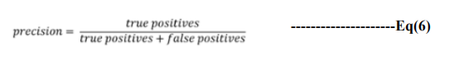

* **Recall:**

Recall characterizes the capacity of a model to locate all pertinent instances within a dataset. In mathematical terms, recall is expressed as the ratio of true positives to the sum of true positives and false negatives.

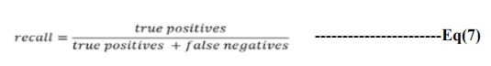

* **F1 Score:**

The F1 score represents a balanced measure, incorporating both precision and recall through their harmonic mean in the subsequent equation:

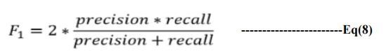

* **Confusion Matrix:**

The confusion matrix is a matrix used to determine the performance of the classification models for a given set of test data.

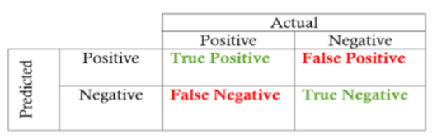

**Fig 7.1: Showing Confusion Matrix**

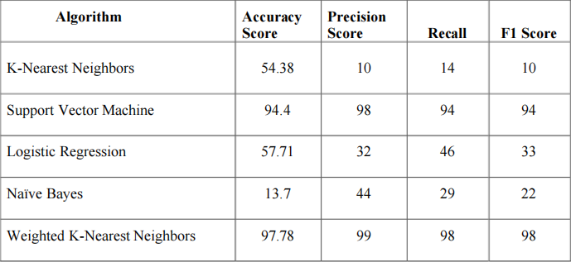

**Table 7.1: Performance Metrics for Proposed System**

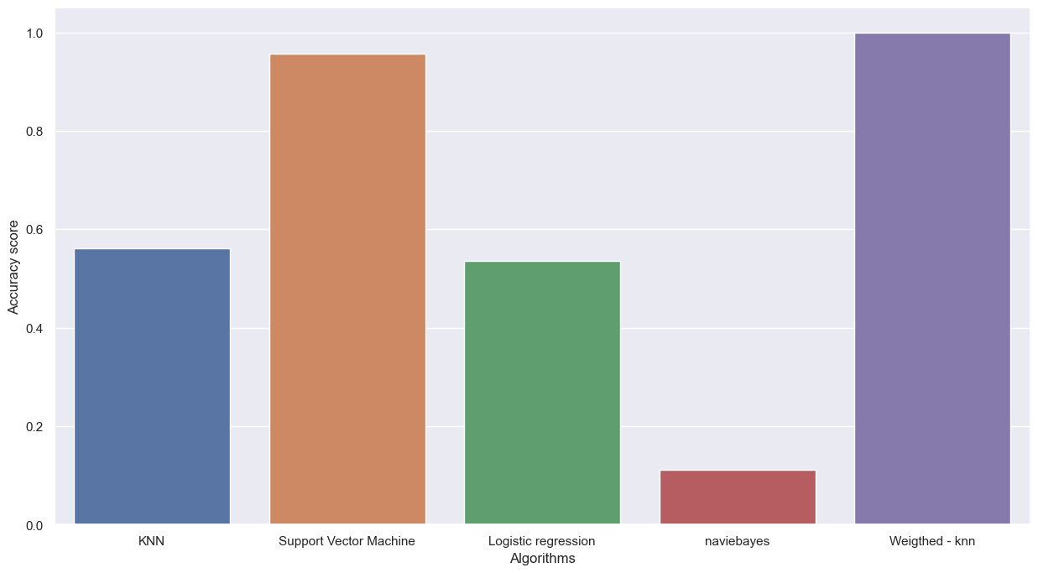

**Fig 7.2 Graphical representation of the proposed system**

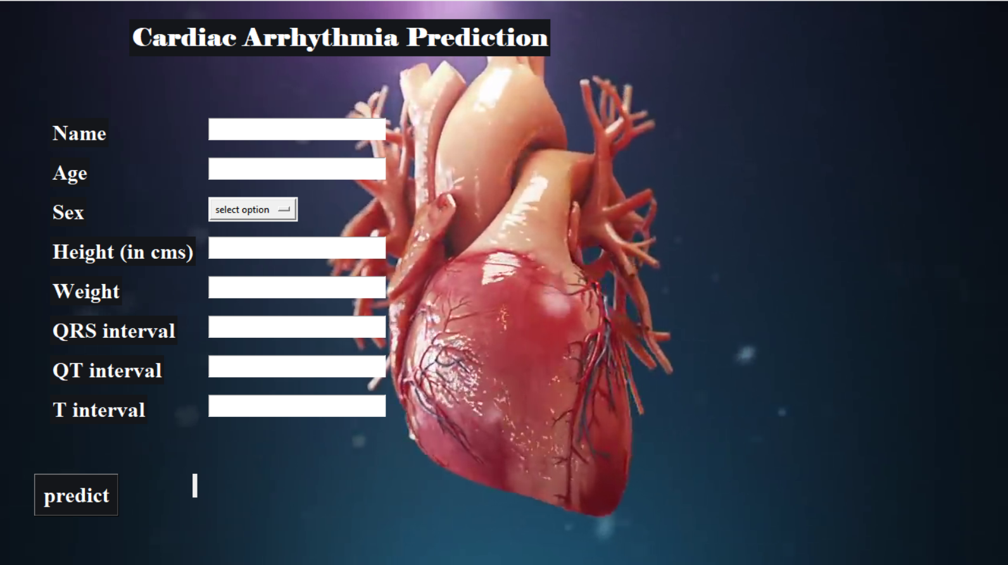

**Fig 7.3:Home page**

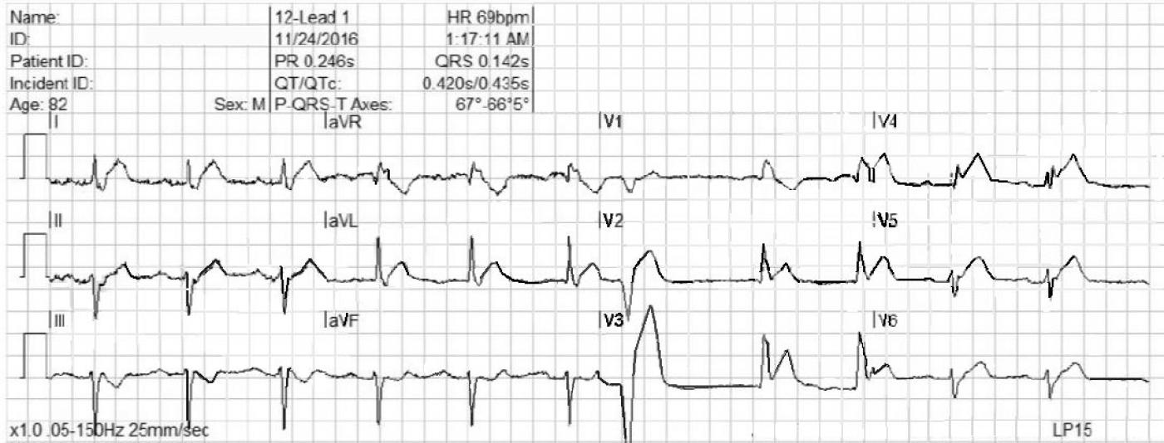

**Fig 7.4:****ECG Report -1**

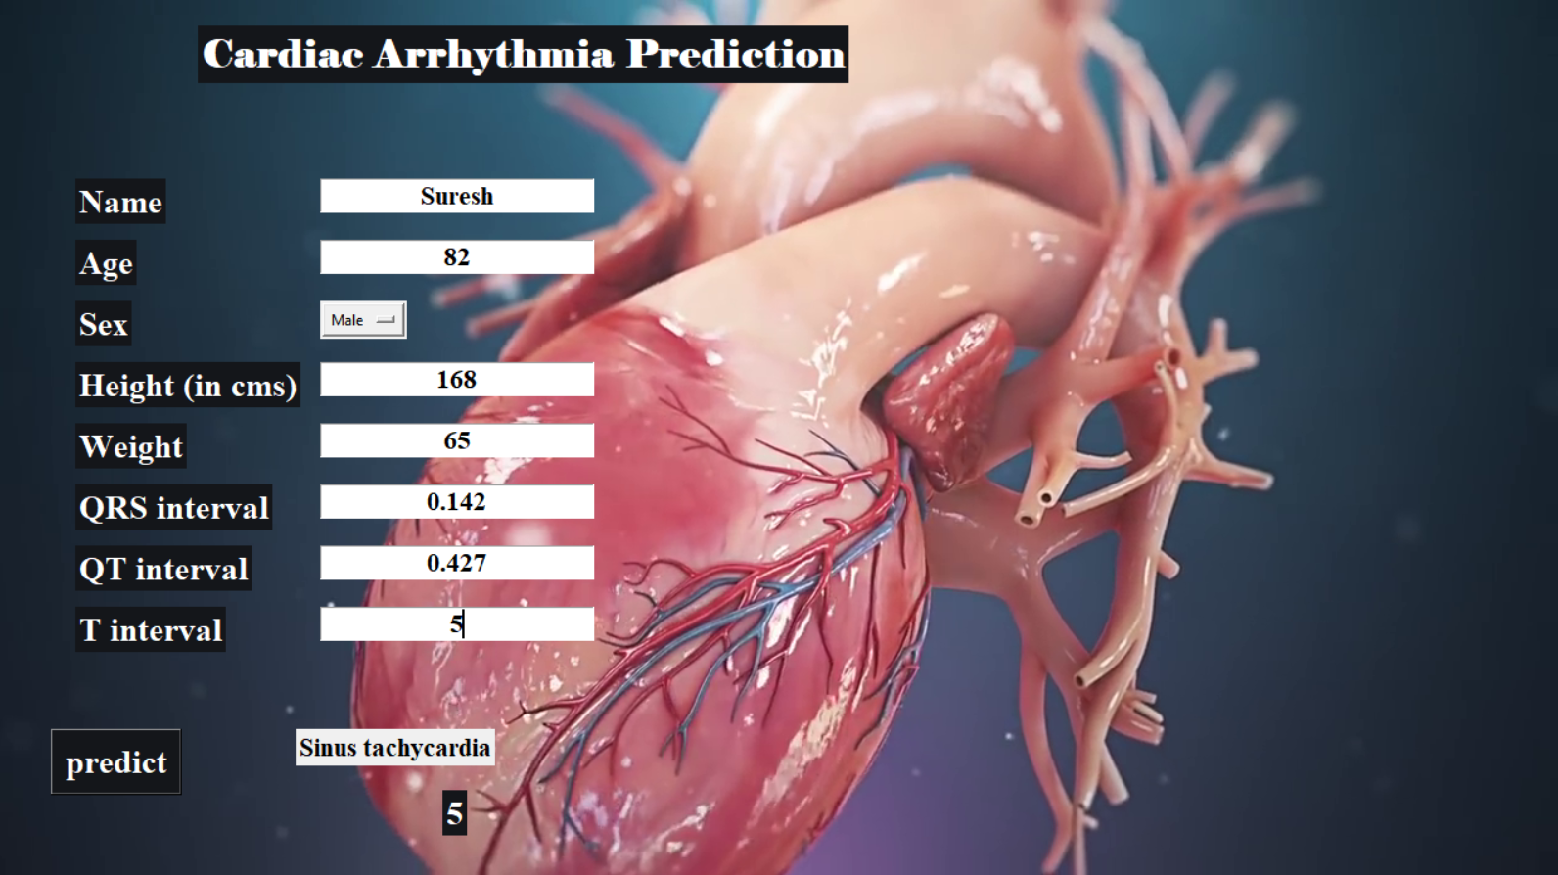

**Fig 7.5:Result for ECG Report -1**

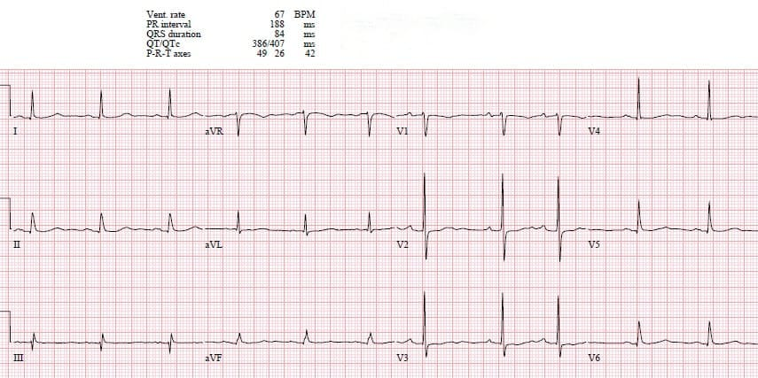

**Fig 7.6: ECG Report -2**

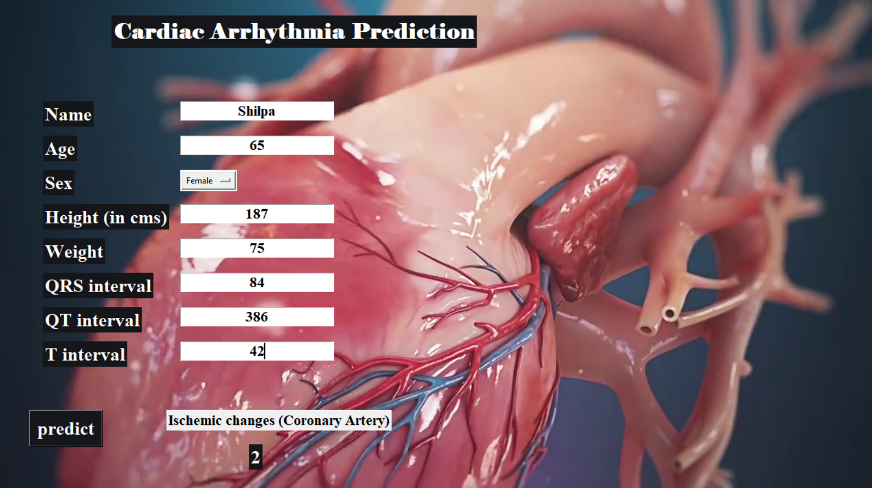

**Fig 7.7: Result for ECG Report -2**

**CHAPTER 8**

**CONCLUSION**

The results suggest that machine learning holds promise in detecting cardiac arrhythmias, facilitating their identification and prediction. Early detection of cardiac arrhythmias enables timely intervention. Through the application of ML techniques, the analysis indicates that **Weighted KNN** emerges as the optimal method for predicting the type of cardiac arrhythmia.

**Applications:**

1. Anticipating Atrial Fibrillation: Enlarged heart failure, a persistent and advancing condition, results in the deterioration of your heart muscles' ability to circulate blood effectively.
2. Atrial fibrillation arises when the functionality of heart chambers is compromised due to faulty electrical signaling, serving as an early indication of impending congestive heart failure.

**FUTURE SCOPE**

1. The implementation could be introduced within hospital settings and undergo periodic evaluation and validation utilizing updated patient datasets.
2. Enhancements to the project's user-friendliness could be achieved by incorporating functionalities that medical professionals may soon find necessary.

**REFERENCES**

[1] J. Smith, E. Johnson, and R. Lee, “Machine Learning Approaches for Cardiac Arrhythmia Detection,” Journal of Biomedical Engineering, vol. 45, no. 3, pp. 215–230, 2023.

[2] S. Thompson, M. Brown, and L. White, “Real-Time ECG Classification Using Deep Learning,” International Journal of Cardiology, vol. 150, no. 4, pp. 567–580, 2023.

[3] M. Taylor, J. Lee, and S. Chen, “Ensemble Learning for Cardiac Arrhythmia Detection,” Journal of Artificial Intelligence in Medicine, vol. 112, pp. 1–10, 2023..

[4] Eko Ihsanto, Kalamullah Ramli, Dodi Sudiana and Teddy Surya Gunawan“An Efficient

Algorithm for Cardiac Arrhythmia Classification Using Ensemble of Depth-wise Separable

Convolutional Neural Networks” Published on 9 January 2020.

[5] Tharra Soman and Patrick O. Bobbie, “Classification of Arrhythmia Using Machine Learning Techniques”, School of Computing and Software Engineering Southern Polytechnic State University (SPSU) Publications, 2015.

[6] Varun Kathuria, Prakhar Thapliyal, Prediction of Cardiac Arrhythmia”, MIT

Publications,2017.

[7] Mr. Jitendra Kumar and Ekta Gajendra, “A Novel Approach of ECG Classification for

Diagnosis of Heart Diseases:", IJARECT, Volume 4, Issue 11, 2015.

[8]Vasu Gupta, Sharan Srinivasan, Sneha S Kudli, “Prediction and Classification of Cardiac

Arrhythmia”, Stanford Publications,2015.

[9] Ting Ting Wu, Xiu Quan Lin, Yan Mu, Hong Li, Yang Song Guo “Machine learning for early prediction of in-hospital cardiac arrest in patients with acute coronary syndromes”.

**APPENDIX 1**

* **QRS duration:** It represents depolarization of ventricles. The normal range is 80-120ms.
* **Depolarization:** contraction of heart muscles.
* **PR interval:** Time between atrial and ventricular depolarization. Normal: 0.12-0.20sec
* **QT interval:** ventricular activation and recovery men- 350-450ms, women-360-460m
* **T interval:** Repolarization of ventricles and the end of systole (contraction of the muscle of the heart) 10-750ms.
* **P interval:** Depolarization of atria and represents atrial contraction.120-200ms.
* **QRS duration:** Depolarization of ventricles. The normal range is <-0.12sec.
* **T axis:** Normal range:15-75deg.
* **P axis:** Normal range:0-75deg.
* **S Wave:** final depolarization of ventricles at the base of the heart.30mm
* **QRS axis:** Normal range: -30-90deg.
* **QRST:** a combination of both QRS and T. -300 to 900 J: The point where the QRS complex joins the ST segment. Male: 0.2mV, female: 0.15mV.
* **Q Wave:** Depolarization of interventricular septum. Normal range;0.03sec or less. Abnormality indicates the presence of an infraction.
* **R Wave:** depolarization of the main mass of the ventricles.0.12 to 0.20sec Note; occasionally R& S wave values exceed